1. (a) What is the distance from 75W longitude to 75E longitude at a

(i) latitude of 0 degrees

6371*cos(0)*(150/180)*Pi = 16,679.21

Ans: 16,679.21 Km

(ii) lat. of 45 degrees

6371*cos(45)*(150/180)*Pi = 11,793.99

Ans: 11,793.98 Km

(iii) latitude of 75 degrees

6371*cos(75)*(150/180)*Pi = 4,316.898

Ans: 4,316.9 Km

(b) What is the width of "zone" 11 of the UTM military grid at 30 deg. latitude?

6371*2*Pi*cos (30)/60 = 577.785

Ans: 577.785 Km

2. Find the great circle distance between the two points. Show some work.

(a) p1: lat. 45deg N long. 115deg W 🡪 p2: lat. 45deg N long. 75deg E

(b) p1: lat. 25deg N long. 140deg W 🡪 p2: lat. 55deg N long. 35deg E

3.

(a) For hw 2. (a), find the distance if one follows a constant bearing of "due West" from p1 to p2.

Due West🡪 360-(115+75) = 170 deg.

6371*cos (45) *(170/180*Pi) = 13,366.54

Ans: 13,366.53 km

(b) Now repeat but for "due East".

Due East🡪 (115+75) = 190 deg.

6371*cos (45) *(190/180*Pi) =14,939.09

Ans: 14,939.096371 Km

4. (a) Give the Quadrant bearing angle corresponding to the azimuth angle of 260 degrees

Ans: S 80 deg. W

(b) Find the azimuth angle that corresponds to S 67deg W

Ans: 180+67 = 247 deg.

5. Search the web for information about one equal-area projection, and one compromise projection (choose either Robinson or Winkel Tripel).

Ans:

Equal-area projection: Hammer projection

It’s presented by Ernst von Hammer. It shows an ellipse and is similar to Mollweide projection, but the latitudes are complex curves. Also, it’s similar to lambert azimuthal projection, but modifies its equation. Both of central meridian and equator are straight lines. Also, the central meridian is half of the length of equator. Other latitudes are curved and parallel to equator. The other longitudes are curved and parallel to central meridian.

The equations are:

Main reference: https://en.wikipedia.org/wiki/Hammer_projection

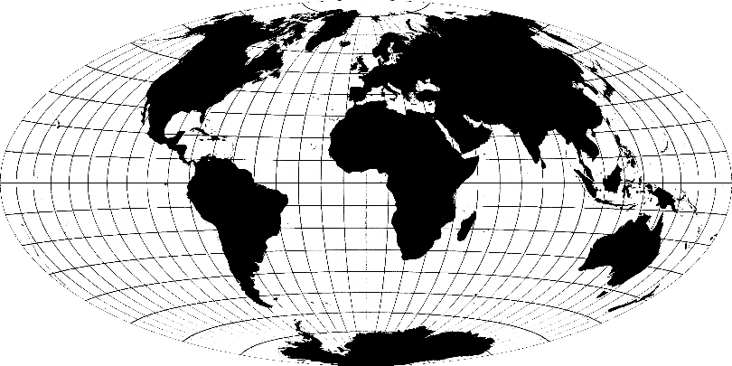 Source: Wikipedia

Compromise Projection: Winkel tripel

Compromise projection has great distortion Arctic circle and Antarctic circle. Therefore, the Greenland seems as same size as U.S. However, the area which is not in polar circle shows close to real sizes. Winkel Triple is an arithmetic mean of two type of projections, equirectangular projection and Aitoff projection. The “triple” means this projection minimizes three kinds of distortion, area, distance, and direction. Both of central meridian and equator are straight lines. The other latitudes are slightly curved. The other longitudes are slightly curved as well. Finally, the projection seems like Robinson projection.

Main reference: http://www.winkel.org/other/Winkel%20Tripel%20Projections.htm

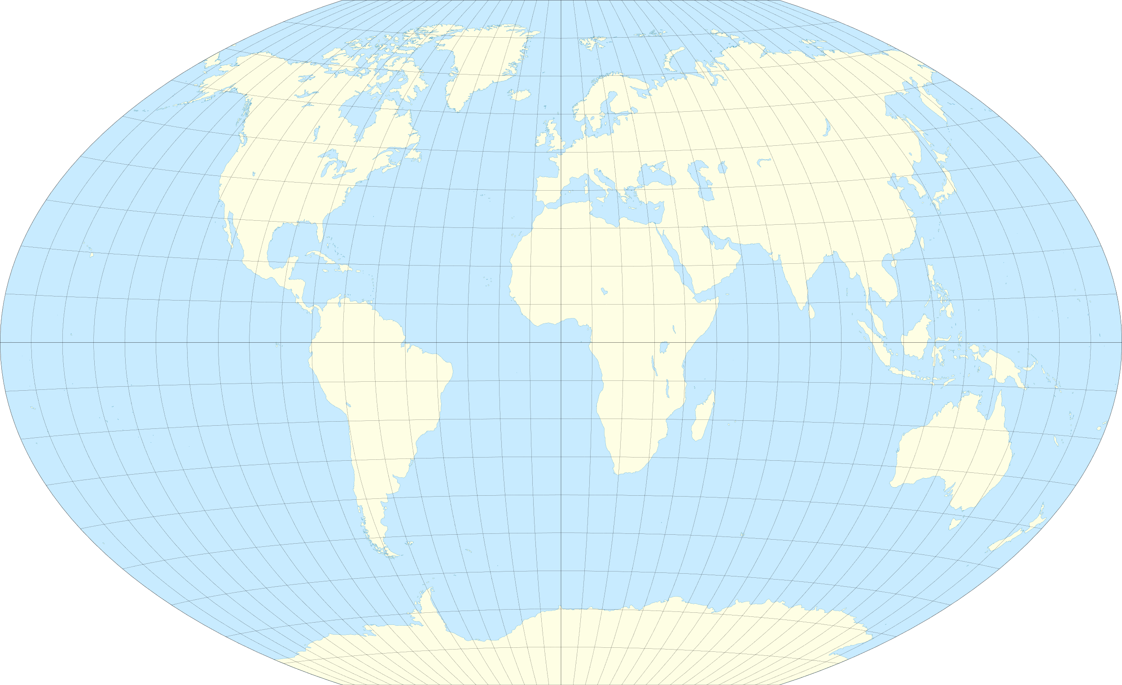 Source: Wikipedia

6. This is about geog coords.

(a) find reasonably accurate longitude, latitude for the Cape Horn

Ans: 55.9833° S, 67.2667° W

(b) if you go due East for 180 degrees from 6.(a), where are you?

Ans: 55.9833° S, 112.7333° E. The place is at south-southeast of Australia and at middle of Australia and Antarctica. Also, it is blue.

(c) find (long.,lat.) for Taupo, New Zealand.

Ans: 38.685884°S, 176.072099°E = 38°41'09.2"S 176°04'19.6"E

(d) what famous movie trilogy was filmed in New Zealand?

Ans: The Lord of the Rings

(e) determine the location of the point antipodal to that in (c);

Ans:

Parallel antipode: 38.685884°S, 3.927901°‬W =

38°41'09.2"S 3°55'40.4"W

It’s at around the center of South Atlantic, and at west of South Africa.

Antipode: 38.685921°N, 3.927878°W = 38° 41' 9.3" N, 3° 55' 40.4" W

It’s in Aldea del Rey. It’s a municipality in the province of Ciudad Real, Castile-La Mancha, Spain.

7. Latitudes of 30.55556 and 30.55553. What is the distance between them in meters? Is it enough for a football field?

Ans: 111000m*0.00003 = 3.33

3.33 meters. It’s not enough.

8. Ratio of areas of Africa and Greenland is 14 to 1.

1. Find the ratio of their populations

Ans: Africa: Around 1.328 Billion

Greenland: Around 56,732

Ratio (Africa: Greenland) = 23,408 : 1

(b) Calculate the ratio of their population densities.

Ans: Ratio (Africa: Greenland) =1,672 : 1